Supervisor: Gerry Moloney
Institution: South East Technological University
Subject: SD3 Project
Purpose of Submission: Software Engineering 3 Project
Date of Submission: 05/02/2026

Blogger Manager - Specification Document
A page that helps people and newspapers to find nearby bloggers based on their location and topics they write about.

C00296913 Reanielle Broas
0. Table of Contents

1. Introduction
1.1 Use Case Diagram
2. Use-Case Description
2.1 Register Blogger Profile
2.2 C.R.U.D* Users
2.3 Moderate Content (Approve/Deny/Delete)
2.4 Search Blogs by Location & Niche
3. Detailed Use Case
3.1 Register Blogger Profile
3.2 C.R.U.D* Users
3.3 Moderate Content (Approve/Deny/Delete)
3.4 Search Blogs by Location & Niche
4. Non-Functional Requirements
4.1 Security
4.2 Performance
4.3 Reliability
4.4 Portability
5.GUI Mockups
5.0 Search Dashboard
5.1 Profile Dashboard
5.2 Rating Dashboard
5.3 Category Dashboard
5.4 Sign Up Dashboard
5.5 Sign Up Dashboard (Blogger)
5.6 Sign up Dashboard (Reader)
5.7 Blogger Starting page
5.8.1 User Starting Page
5.8.2 User Starting Page

Use-Case Diagram

1.1 Use Case Diagram
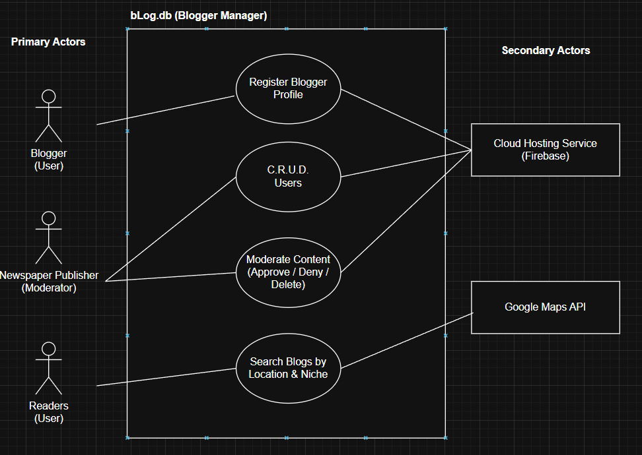
Fig 1.0 Blogger Manager Use Case Diagram, Reanielle Broas (2026)

Use-Case Description

2.1 Register Blogger Profile
Actors: Blogger (Users), Cloud Hosting Service (Firebase)
Description: This use case begins when the Blogger wishes to register for a blogger profile. The details in the registration include their email, username, password, domain link to their content, tags/filters of their content, and geolocation. The Blogger Manager application will send this new information to the cloud hosting service. The use case ends when the Blogger has submitted their registration form and it has been sent to the Cloud Hosting Service for Moderators to review.

2.2 C.R.U.D* Users
Actors: Newspaper Publisher (Moderator), Cloud Hosting Service (Firebase)
Description: This use case begins when the Moderator wishes to Create, Read, Update or Delete User account information. The details of the user include user ID, user email, user password, user geolocation. It may also include blogger domain links to their content, and blogger tags/filters. The Blogger Manager application will send this new information to the cloud hosting service. The use case ends when the user or moderator has finished their work in relation to the user/s account.

2.3 Moderate Content (Approve/Deny/Delete)
Actors: Newspaper Publisher (Moderator), Cloud Hosting Service (Firebase)
Description: This use case begins when the Moderator wishes to Approve/Deny/Delete content from the Blogger Manager. The details of content differ as it can either be Blogs (titles, domain link, tags, geolocation), Reviews (title, message), or Comments (message), content will also be associated with the User ID. The application will send this new information to the backend database. The use case ends when the Moderator has finished their work in relation to the content.

2.4 Search Blogs by Location & Niche
Actors: Readers (Users), Google Maps API
Description: This use case begins when the Reader wishes to search for a blog by its location (radius, or definite), or niche tag/category filter/s. The details of the blogs include title, domain link, tags, and geolocation. The use case ends when the blogs are returned to the Reader for viewing, filtered by the readers criteria.

* Create, Read, Update, and Delete (C.R.U.D.).

Detailed Use Case

3.1 Register Blogger Profile
Actors: Blogger (Users), Cloud Hosting Service (Firebase)
Pre-condition: Blogger has the website up or application installed and has a valid email address.
Main success Scenario:
- This use case begins when the Blogger wishes to register for a blogger profile.
- The blogger enters account credentials (email, username, password)
- The blogger provides content details (domain link to content, and selects niche tags/filters).
- The blogger provides Geolocation via GPS or manual entry.
- Application validates that all mandatory fields in the registration form are filled.
- The Blogger Manager application will send the data to the cloud hosting service.
- The system creates a “Pending” profile record.
Alternatives:
*3a. The domain link is invalid or unreachable
>> The app alerts the user to verify their URL before re-submitting
*6a. The cloud service is offline or fails to respond
>>To be detailed later in further iterations
Post-condition: Registration is submitted and the profile is hidden from search until approved by a moderator.

3.2 C.R.U.D* Users
Actors: Newspaper Publisher (Moderator), Cloud Hosting Service (Firebase)
Pre-condition: N/A
Main success Scenario:
- This use case begins when the Moderator wishes to Create, Read, Update or Delete User account information.
- The moderator searches for a specific user using User ID, email, or geolocation.
- The application fetches the relevant data from the Cloud Hosting Services (Firebase).
- The moderator performs the necessary modification (e.g. updating a bloggers niche tag, or deleting a bot/spam account).
- The Blogger Manager application sends this updated information back to the Cloud Hosting Service.
- The use case ends when the moderator has finished their work in relation to the user/s account.
Alternatives:
*3a. User ID does not exist in the database
>> The system will display an “Account Not Found” error alert.
Post-condition: The database shows the updated user information.

3.3 Moderate Content (Approve/Deny/Delete)
Actors: Newspaper Publisher (Moderator), Cloud Hosting Service (Firebase)
Pre-condition: N/A
Main success Scenario:
- This use case begins when the Moderator wishes to Approve/Deny/Delete content from the Blogger Manager.
- The moderator accesses the moderation dashboard, which fetches a list of pending or reported content from the Cloud Hosting Service.
- The details of the content are displayed, including Blogs (titles, domain links, tags, geolocation), Reviews (title, message), or Comments (message), all associated with a specific User ID.
- The moderator checks the content for compliance with safety standards (e.g. No hate speech/defamation). Making sure it doesn’t go against the rules and terms of service of the platform.
- The moderator selects an action:
  - Approve: Marks the content as "Verified" and makes it visible to Readers.
  - Deny: Rejects the content and sends a notification/reason to the Blogger.
  - Delete: Permanently removes the content from the platform.
- The system updates the content status in the cloud hosting database.
Alternatives:
*2a. The Cloud Hosting Service (Firebase) fails to fetch the pending queue:
>> The system displays a connection error message and the moderator is
asked to try reconnect again.
*4a. Content violates the Digital Services Act (Safety Risk).
>> The moderator flags the account for permanent suspension.
*4b. The moderator identifies a repeat offender.
>> The moderator may choose to take action by triggering C.R.U.D. Users
use-case to suspend the offender's account.
Post-condition: Only approved content is visible to the public reader.

3.4 Search Blogs by Location & Niche
Actors: Readers (Users), Google Maps API
Pre-condition: N/A
Main success Scenario:
- This use case begins when the Reader wishes to search for a blog by its location (radius, or definite), or niche tag/category filter/s.
- The reader opens the dashboard for searching.
- The reader enters a location (e.g. “Kildare”) and selects a radius (e.g. “10 km”).
- The reader selects a Category, and selects one or more Niche tags (e.g. “Drag race cars”).
- The system filters the database for bloggers within the category, matching for niche tag/s and the geolocation radius.
- The application displays the filtered list of the bloggers, blog titles and domain links.
Alternatives:
*3a. Google Maps API fails find the location entered
>> The application asks the user to provide a more specific postcode
, address , or suggest GPS.
*5a. No blogs are found within the specified radius:
>> The application suggests increasing the search radius or changing the filter.
Post-condition: Reader is present with verified local content matching their specific criteria.

Non-Functional Requirements

4.1 Security
- All data access must be governed by the Firebase Security Rules, ensuring that only authorized Moderators can write to the “Verified” collection of users.
- All user credentials and personal data must be encrypted at rest using AES-256 and in transit via TLS 1.2 or higher.
- Any data used for public analytics must be shown anonymized to prevent the identification of specific users, or their payment details.

4.2 Performance
- Geolocation search results must be returned to the user in less than 2 seconds.
- The application must support at least 500 concurrent users without an increase in page load times.
- Content approved by a moderator must appear in search results within 30 seconds across all platforms.

4.3 Reliability
- Automated database backups to Firebase must occur every 24 hours.
- In the event of a service failure, the system must be restored to full functionality within 4 hours.

4.4 Portability
- The mobile application must be optimized to run on devices with a minimum of 2GB or RAM.
- The system must be fully functional on Android 11+. iOS 15+, and the latest versions of Chrome, Safari, and Opera.
- The UI/UX must maintain 90% visual similarity between the Flutter mobile app and its web interface.

5.GUI Mockups

5.0 Search Dashboard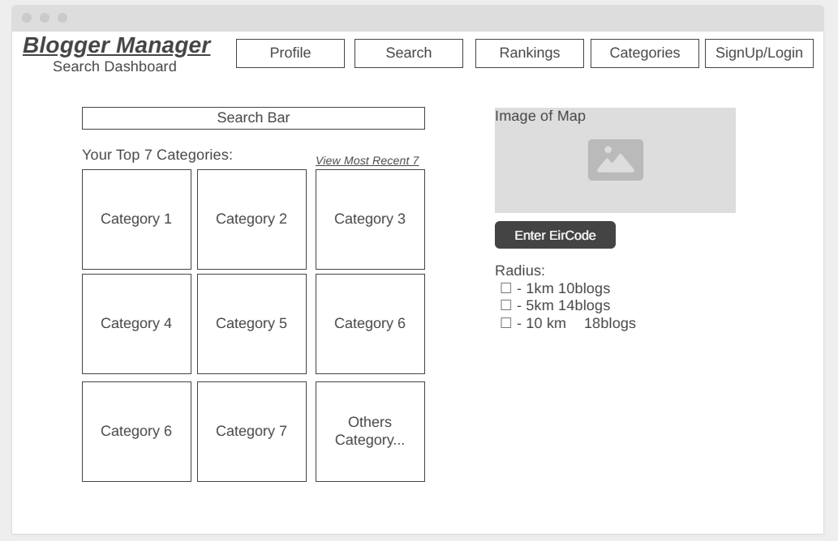

5.1 Profile Dashboard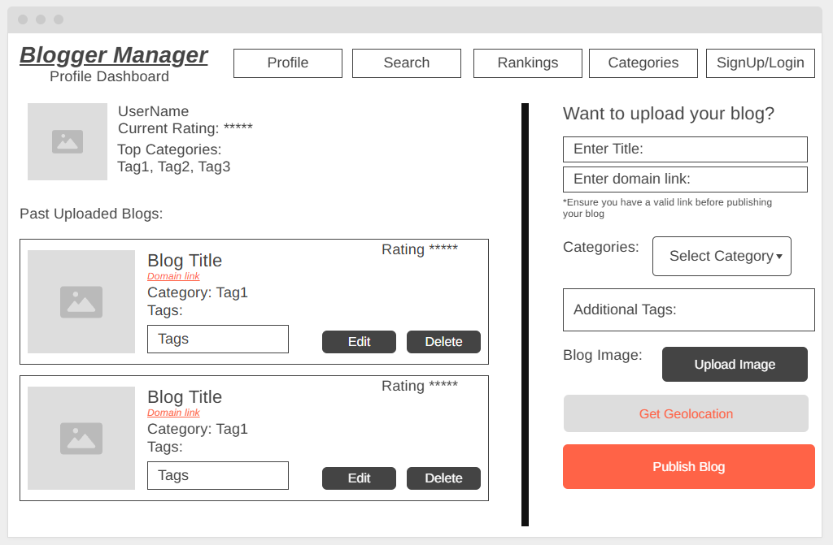

5.2 Rating Dashboard

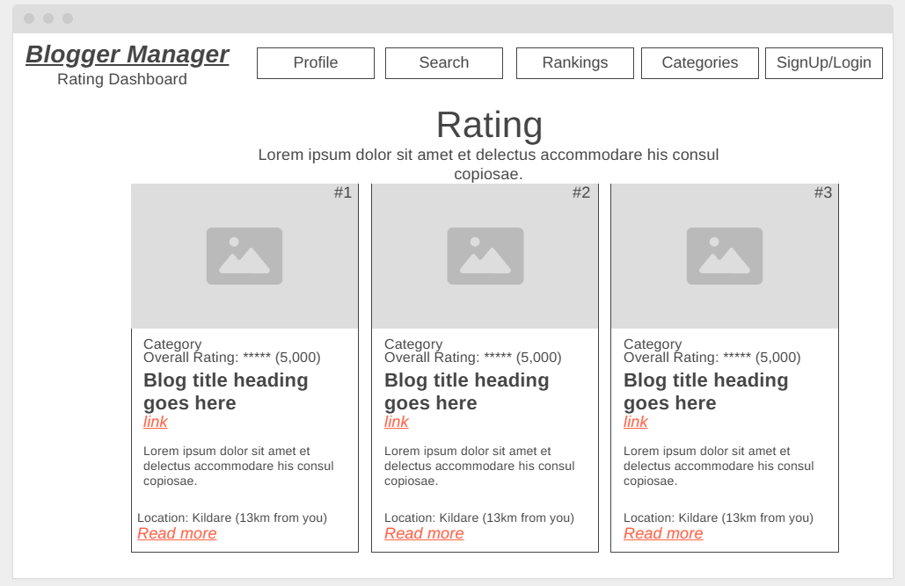

5.3 Category Dashboard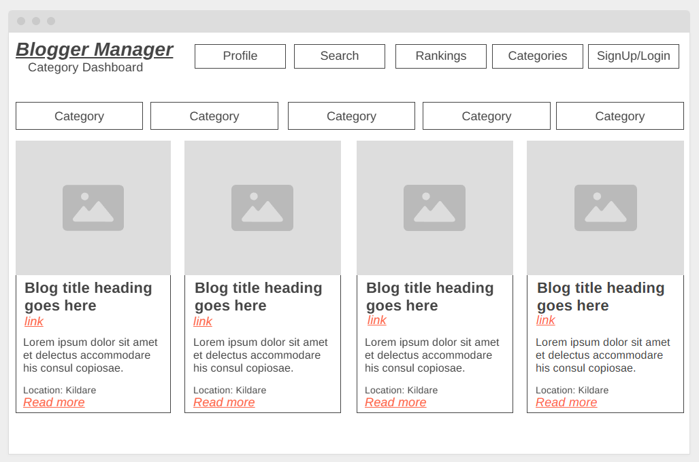5.4 Sign Up Dashboard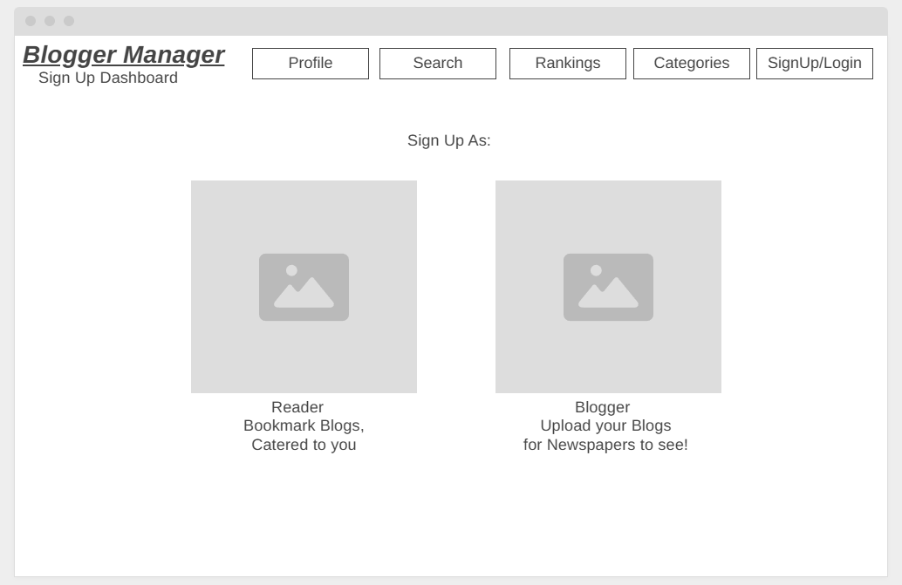

5.5 Sign Up Dashboard (Blogger)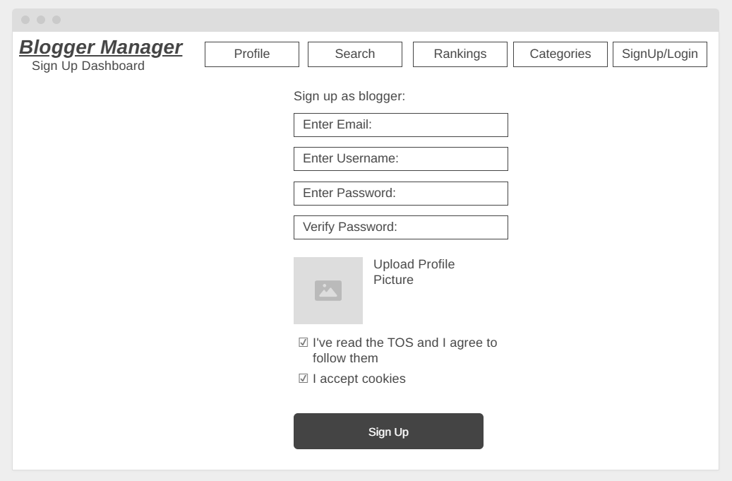5.6 Sign up Dashboard (Reader)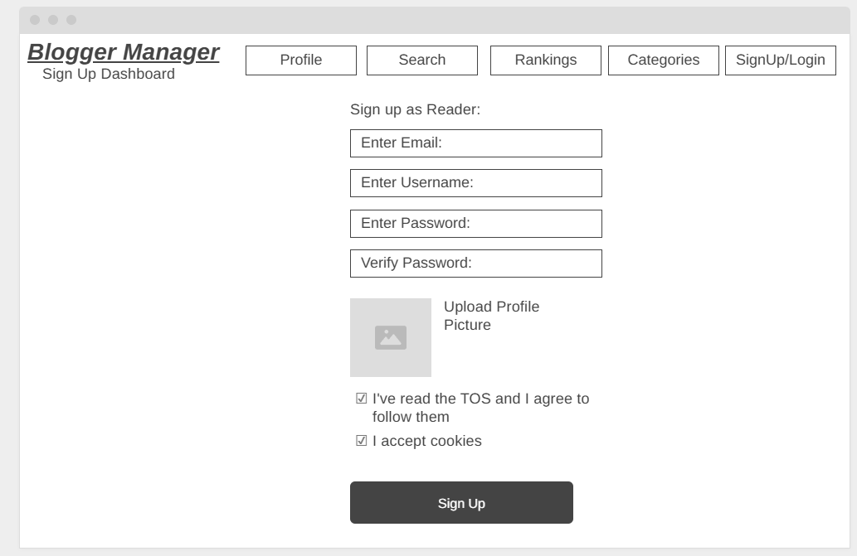

5.7 Blogger Starting page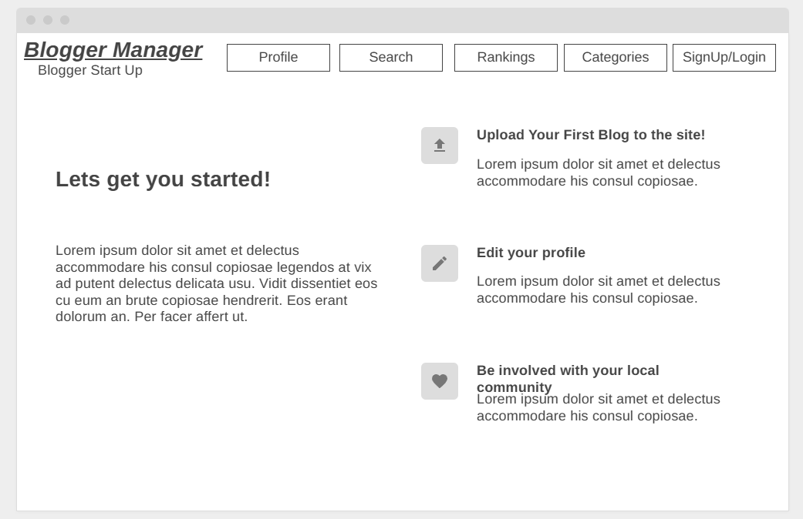5.8.1 User Starting Page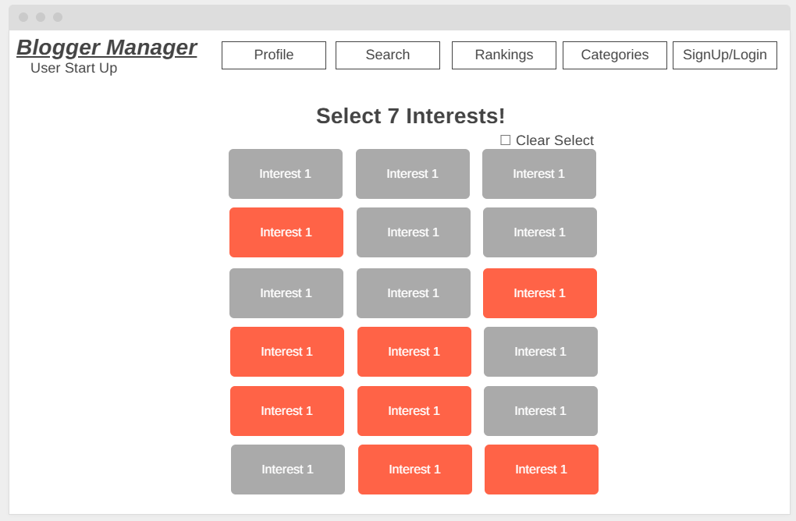

5.8.2 User Starting Page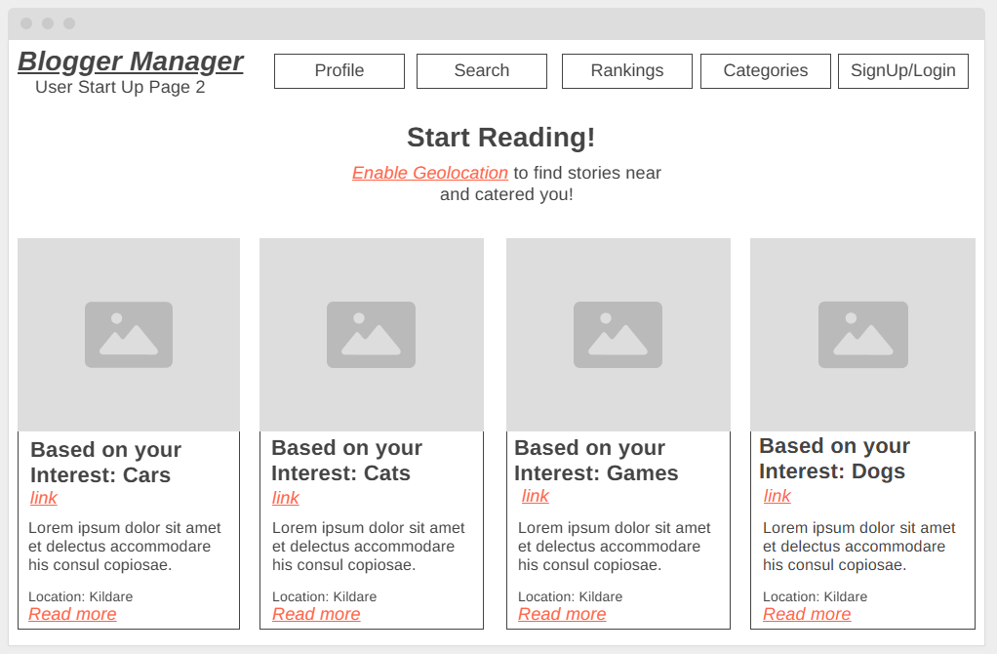5.9 Moderation Suite
